Overview
To run the deregistration report for outreach or review only, you need to perform these steps:
- Go to GKAPEXE to run the MDUDREG process. This process can be safely run at any time for preparing draft reports for outreach, etc. It should be run by so the new results will be included in the scheduled Cognos report.
- Use Cognos to generate a spreadsheet with the draft deregistration data. This will happen automatically at and send the resulting spreadsheet to Student Accounts. If you want to get an updated spreadsheet at another time, you can run a Cognos report manually and it will generate a new spreadsheet using the data from the most recent MDUDREG run.
- Review the Cognos report, especially the RUN_DATE column that shows you when the MDUDREG process was last run, since a spreadsheet is sent out on a schedule regardless of whether anyone has run MDUDREG to update the data today.
To complete the actual deregistration and drop students from courses for non-payment:
- Apply TDREGPRO comments to anyone who should not be deregistered. Anyone with an active TDREGPRO comment will be protected from deregistration regardless of balance or other factors.
- Go to GKAPEXE to run the MDUDREG process. When run, this process will go through four stages:
  - PREP: Identify the students enrolled for the term and lookup charges, memos, aid, enrollment data, part-of-term data, etc.
  - CALC: Using that data, calculate their total balance, and decide who should be protected based on their learner record, part-of-term enrollments, or latest enrollment activity date.
  - DEREG: Based on the balance and the protection statuses, determine who should be deregistered.
  - FLAG: Update the SFBETRM record’s AR indicator field to indicate whether the student should be deregistered or not.
- Use Cognos to manually generate a spreadsheet with the draft deregistration data.
- Review the spreadsheet as a final sanity check. Are the numbers comparable/expected? Any last minute changes can be made by adding the TDREGPRO comment at this time.
- Return to GKAPEXE to run the MDUDREG process again to refresh the data for any recent TDREGPRO changes and new enrollments.
- Use the GKAPUNV Universal Viewer screen to quickly review the MDUDREG data and confirm the numbers match what is expected. This should be done as quickly as possible, since any registration activity during this period could result in someone being deregistered incorrectly. Note that this screen will not show all the report columns we added for outreach purposes, just the core columns used by the MDUDREG process itself, but it is faster than running the full spreadsheet in Cognos so it can be used for a quick check of numbers.
If this takes more than a minute or two, go back to the prior step and re-run the MDUU process again.
- Run the Banner deregistration process as quickly as possible. Compare the count of affected users to the number expected from MDUDREG data.
- Use Cognos to generate a spreadsheet with the final deregistration data. This spreadsheet should be saved for future reference.
- Send notifications to the people deregistered.

Run the MDUDREG Process
In Banner PROD, go to the GKAPEXE screen.  Select the process code MDUDREG and click Go. | 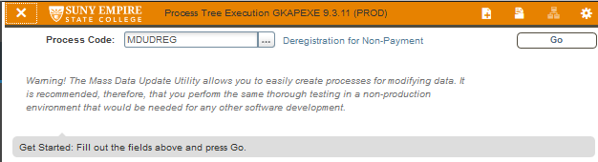
On the initial tab labeled Execution Tree Set-up, click the Compile Tree button. After clicking the button, the large display area in the right column should say:  MDUDREG_PREP_A verified as 'enabled with purge'.  MDUDREG_DREG_A verified as 'enabled'.  MDUDREG_CALC_A verified as 'enabled'.  MDUDREG_FLAG_A verified as 'enabled'.  Note: This step may only be needed the first time for each user, or if the programming has been updated. However, it should not hurt to do it every time and it guarantees you won't miss any bug fixes we make. | 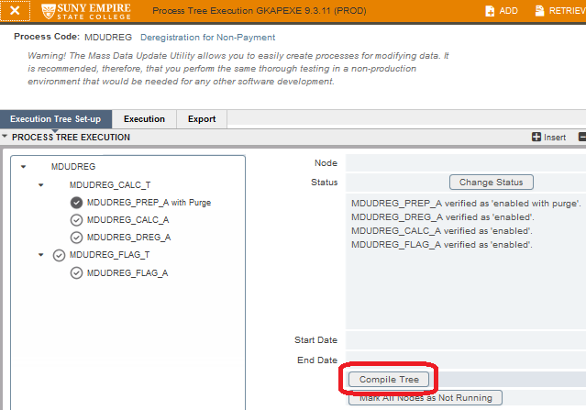
Switch to the Execution tab. In the Parameter Value column, enter:  - Banner Term Code: The 6-digit term, i.e. 201950.  - Balance: The balance threshold at which point students get deregistered, i.e. 300 or 1000.  - Purge Before Populate: Should always be a Y.  - Begin: Earliest part-of-term start date you want to process for deregistration. Any part-of-term that started before this date will be considered a “prior part-of-term” (see below).  - End: Latest part-of-term start date you want to process for deregistration. Any part-of-term that starts after this date will be considered a “future part-of-term” (see below).  - Cutoff: Anyone who has registration activity on or after this date will be protected from deregistration. For draft runs for outreach purposes, it should probably be in the future so everyone is processed. For the actual deregistration, it is usually set to the current date so that anyone who registered today will be protected.  In the Run/Execution block, you need to set the Execution Mode to UPDATE and Exception Mode to Log and Abort. If you want to do a test run first, execution mode can be set to AUDIT instead but nothing will happen except you’ll see whether it runs successfully or has an error.  Click the Run Now button.  Click Yes when you see the Confirm Direct Run popup that warns that it will tie up your session until complete.  Wait for the job to finish, which usually takes 1 to 2 minutes. If it runs successfully, there will be a blue completion message. Click OK.  If there are errors, you will see an error message. You can view the error log by clicking on the TOOLS menu and selecting View SQL Log. | 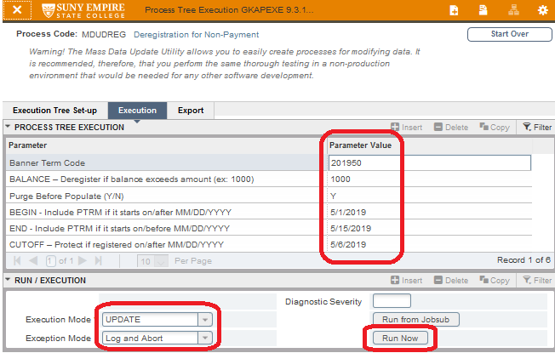  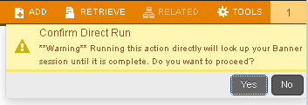  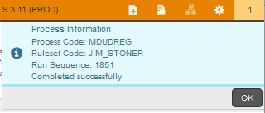  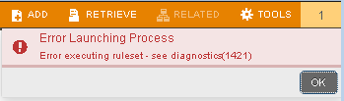

Quickly Review Data in GKAPUNV
Go to GKAPUNV to view the results of the last MDUDREG run.  - Select MDUDREG for the Table Name.  - For the first Filter Column, enter or select MDUDREG_99_TERM. If you use the popup select window, it will be the last element on the 3rd page.  - For the first Filter Value, enter the term, ex. 201950.  - Additional filters can be added here. For example, you could also filter the MDUDREG_01_DEREG column to be “Yes” if you only want to see who will be deregistered.  - Click Go. | 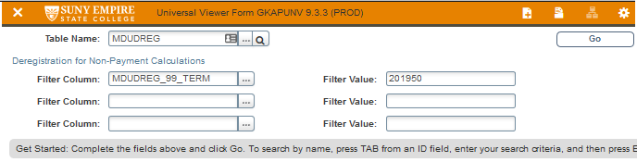
Quickly review the latest MDUDREG results.  The number of rows is shown in the bottom left corner of the data pane.  If you are looking at all the records but want to sort them by whether they are deregistered or not, you can sort any column by clicking on the column label. Clicking the column label again will toggle between sorting ascending or descending, as shown by a triangle on the right edge of the column label.  You can add additional filters by clicking the Filter button in the top right corner of the data pane. You cannot remove filters you applied in the key block, so if you want to remove those filters you need to use the Start Over button. | 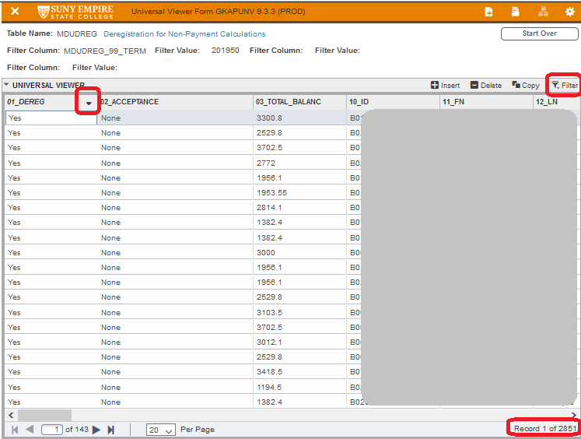

Generate the Deregistration for Non-Payment Spreadsheet in Cognos
During the period leading up to a term start, ITS can configure Cognos to automatically email the latest copy of the MDUDREG data on any desired schedule. Contact Jim Stoner for assistance changing the configured times. Please note that this automatic report will only display the data from the last time MDUDREG was run. You will need to manually run the MDUDREG process before the daily Cognos report is scheduled to run if you want to have an updated spreadsheet.
If you need to create the Cognos spreadsheet manually at another time, you can follow these steps:
Log into the Cognos home page for the production system at:  https://banner.esc.edu:9300/bi/?perspective=home  In the left navigation menu, click on Team Content.  Click on the Banner Production Reports folder.  Click on the Deregistration for NonPayment folder. | 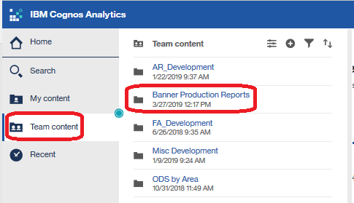
Click on the Deregistration for NonPayment report to open the parameter screen.  Confirm that the report will be downloaded as Excel data, as shown near the top of the screen.  Enter the desired term code.  Hit the Finish button.  The report will take 1-2 minutes to be created and downloaded. | 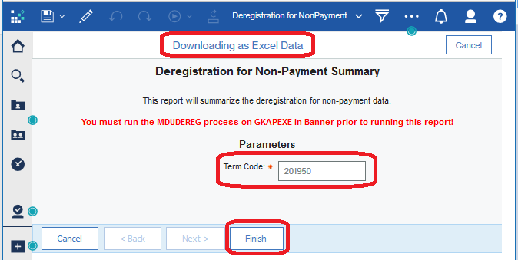

Deregistration Spreadsheet Details
A summary of columns that may be either ambiguous or used in calculations is included here.
Most of the data in the spreadsheet will be accurate as of the last time MDUDREG was run, as specified in the RUN_DATE column. Columns with an asterisk after their name in the list below were added to the spreadsheet later for outreach purposes (primarily financial aid info) and will be accurate as of the time the spreadsheet is created by Cognos, so there may be a slight variation depending on how long it has been since the last MDUDREG was run.
For this spreadsheet, financial aid fund codes are grouped as follows: State aid includes SMRS, SNYTC, STAP, SXCEL, SXCLTC; Part Time aid includes SAPTS; and Federal aid is all other fund codes.
- TERM: The term the MDUDREG data was run for.
- RUN_DATE: The time the MDUDREG process was last run for this term.
- DEREG: Either Yes or No, indicating whether the student was flagged for deregistration at the time the MDUDREG was run.
- TOTAL_BALANCE: The sum of the current term and prior term balances, minus any current/prior term memos, authorized federal or state aid, etc. Amounts from future terms are not included in this balance.
- LAST_REGISTERED*: The most recent term, prior to the term we are reporting on, that the student has either an active or withdrawn enrollment record in SFRSTCR or an academic history record in SHRTCKN.
- AIDYR*: The aid year specified in the rovterm_fa_proc_yr field for the current term.
- FA_APPL_RCVD*: The application received date from the rorstat_appl_rcvd_date field for the current aid year.
- FA_VERIFICATION*: The verification flag from rorstat_tgrp_code for the current aid year.
- FA_MISSING*: A list of codes from the RRRAREQ_TREQ_CODE field that are marked as not satisfied in RRRAREQ_SAT_IND.
- FA_FED_ACCPT*: The sum of the accepted amounts (rpratrm_accept_amt) for federal aid fund codes this term.
- FA_FED_AUTH*: The sum of the authorized amounts (rpratrm_authorize_amt) for federal aid fund codes this term.
- LAST_CONTRACT*: The most recent term the student has a record in TBBCSTU.
- ACTIVE_HOLDS*: A list of all active holds in SPRHOLD.
- MILITARY_ATTRIBUTES*: A list of active attributes from a predefined list of military codes, currently:
('NATG', 'RESV', 'VETR', 'VETS', 'VETD', 'USCG', 'USMC', 'ARNG', 'AING', 'ACTS', 'ACTD', 'NAVY', 'ARMY', 'USAF', 'MILT', 'MILS', 'ACT', 'MILG')
- OTHER_ATTRIBUTES*: A list of all active attributes except the military attributes defined in the prior column.
- 01_DEREG: Either Yes or No, indicating whether the student was flagged for deregistration at the time the MDUDREG was run. Same as the earlier column DEREG, which was copied earlier in the spreadsheet for ease of use by the outreach team.
- 02_ACCEPTANCE: This is the value that actually gets assigned on the SFBETRM record. A value of NONE means the student will be deregistered, while a value of ACCEPTED means the student will not be deregistered.
- 03_TOTAL_BALANCE: The calculated balance using the following formula and referring to the columns below:
  - Current/prior term balances from 30_TERM_BALANCE plus 31_PRIOR_BALANCE (future term balances not included!)
  - Minus current/prior memos from 35_TERM_MEMOS and 36_PRIOR_MEMOS
  - Minus current/prior federal aid from 40_TERM_FED_AUTH and 41_PRIOR_FED_AUTH
  - Minus current/prior state aid from 50_TERM_ST_AUTH and 51_PRIOR_ST_AUTH
  - Minus current/prior part time aid from 55_TERM_APTS_AUTH and 56_PRIOR_APTS_AUTH
- 20_TDREGPRO: Indicates if there is an active, not yet ended, TDREGPRO comment.
- 21_EXCL_LEARNER: Indicates if the student is protected due to information on their learner record. Currently this includes anyone in college 50, or anyone with the attributes PLUB, IB20, IB3N, or IBEW.
- 22_EXCL_PTRM: Indicates if the student is protected because they have enrollments in a prior part of term, or if their only enrollments are in a future part of term. For more details, see the full explanation below.
- 23_EXCL_DATES: Indicates if the student has registration activity on or after the registration cutoff parameter specified when running the job. This protects people who enrolled very recently and won’t have had a chance to make payment arrangements yet.
- 24_EXCL_OTHER: Currently unused, placeholder for future exceptions.
- 30_TERM_BALANCE: Sum of TBRACCD balances in the current term. Future terms are not included.
- 31_PRIOR_BALANCE: Sum of TBRACCD balances from prior terms.
- 32_PRIOR_AG_BAL: Sum of TBRACCD balances with a detail code starting with DA…
- 35_TERM_MEMOS: Sum of TBRMEMO amounts for the current term with future expiration dates. Future terms are not included.
- 36_PRIOR_MEMOS: Sum of TBRMEMO amounts from prior terms with future expiration dates.
- 40_TERM_FED_AUTH: Sum of RPRATRM authorized amounts for Federal fund codes in the current term.
- 41_PRIOR_FED_AUTH: Sum of RPRATRM authorized amounts for Federal fund codes in prior terms.
- 50_TERM_ST_AUTH: Sum of RPRATRM authorized amounts for State fund codes in the current term.
- 51_PRIOR_ST_AUTH: Sum of RPRATRM authorized amounts for State fund codes in prior terms.
- 55_TERM_APTS_AUTH: Sum of RPRATRM authorized amounts for Part Time fund codes in the current term.
- 56_PRIOR_APTS_AUTH: Sum of RPRATRM authorized amounts for Part Time fund codes in prior terms.
- 60_DREG_BEGIN: The BEGIN parameter on GKAPEXE when this report was run. Parts of term that start between this date and the END date are considered current parts of term for this run of the job. See the explanation of parts of term below for details.
- 61_DREG_END: The END parameter on GKAPEXE when this report was run. Parts of term that start between the BEGIN date and this END date are considered current parts of term for this run of the job. See the explanation of parts of term below for details.
- 62_FIRST_PTRM_START: The start date of the earliest part of term that this student has enrolled in.
- 63_LAST_PTRM_START: The start date of the latest part of term that this student has enrolled in.
- 64_CURR_PTRM_CREDITS: Sum of credits for enrollments in parts of term that start between the BEGIN and END dates for this run of MDUDREG.
- 65_PRIOR_PTRM_CREDITS: Sum of credits for enrollments in parts of term that started before the BEGIN date for this run of MDUDREG.
- 66_LATER_PTRM_CREDITS: Sum of credits for enrollments in parts of term that wil start after the END date for this run of MDUDREG.
- 67_TOTAL_CREDITS: Sum of credits in this term, regardless of part of term.
- 68_DREG_PTRMS: List of parts of term the student has enrollments in.
- 70_FIRST_REG_DATE: The earliest registration date for this student in this term (SFRSTCA_ADD_DATE).
- 71_LAST_REG_DATE: The most recent registration date for this student in this term (SFRSTCA_ADD_DATE).
- 72_REG_CUTOFF: The CUTOFF parameter from GKAPEXE when this process was run. Students with a LAST_REG_DATE equal to or greater than this cutoff will be protected from deregistration.
- 80_COLL_CODE: The first college code (SGBSTDN_COLL_CODE_1) in the maximum term effective learner record (up to current term) where they are eligible to register.
- 81_DEGC_CODE: The first degree code (SGBSTDN_DEG_CODE_1) in the maximum term effective learner record (up to current term) where they are eligible to register.
- 82_MAJR_CODE: The first major in the first degree (SGBSTDN_MAJR_CODE_1) in the maximum term effective learner record (up to current term) where they are eligible to register.
- 83_LEVEL: The level code for the first degree (SGBSTDN_LEVL_CODE) in the maximum term effective learner record (up to current term) where they are eligible to register.
- 84_MATRIC_STATUS: A value of N indicates the student is a Non-Matric in their maximum term effective learner record (up to current term), while an M indicates a Matric.
- 85_PROG_STATUS: The status of their learner record/program in the maximum term effective learner record (up to current term) where they are eligible to register.
- 86_SITE_CODE: The site code from the learner record in the maximum term effective learner record (up to current term) where they are eligible to register.
- 88_COHORTS: A list of student cohorts (SGRCHRT_CHRT_CODE) from the current term.
- 89_ATTRIBS: A list of student attributes (SGRSATT_ATTS_CODE) from the current term.
- 90_US_CITIZEN: Placeholder, not currently used.
- 91_NY_RESIDENT: Placeholder, not currently used.
- 96_ACTIVITY_DATE: The date this record was processed in MDUDREG.
- 97_ID_COLLEAGUE: The 7-digit Colleague ID.
- 98_PIDM: The Banner SPRIDEN_PIDM id.
- 99_TERM: The term this MDUDREG job was run for.
* These columns are calculated when the Cognos spreadsheet is created, so they may be more recent than the rest of the MDUDREG data.

Deregistration Calculation Details

Parts of Term
The rules regarding parts of term are below. When running the MDUDREG process, we specify the earliest and latest part of term start dates to include in this run. Any parts of term that start within that range are the “current parts of term”, while those that started before that range are considered “earlier parts of term”, and any that start after that range will be “later parts of term”. The rules below are checked in order, stopping on the first “match”, so if someone would be in both category 1 and category 3, the rule 1 will apply.
1. If a student has enrollments in an earlier part of term (which presumably went through dereg earlier so they must have been paid up at that point), they will NOT be deregistered for the current run. Reason: the deregistration process would remove them from all courses, not just the specific part of term courses we’re processing in this run, so we did not want to have them dropped from earlier courses they presumably paid for already. So anyone with a course in SU1 or SU2 will not be deregistered when we run it for SU3, and they will need to be manually reviewed if you want them deregistered from SU3 only.
2. If a student has no enrollments in the current part of terms but does have enrollments in a later part of term, they will not be deregistered in the current run. Reason: someone enrolled only in later parts of term don’t need to be deregistered at the start of the main term. They presumably still have time to make payment arrangements before the start of their part of term. For Summer, that means someone only in SU3 will not be processed when running it for SU1/SU2.
3. If a student has enrollments in both the current part of term and a later part of term, they are NOT protected and will be deregistered from all parts of term if their total balance is over the threshold. Reason: the Banner deregistration process does not consider parts of term: either we drop them from all courses, or we don’t drop them from any. The decision was that students with enrollments in the current and later parts of term (but not earlier parts of term) would be dropped from all courses if their combined balance was over the threshold.

SFRNOPP Limitations
The out of the box deregistration for non-payment process in Banner relies on the flag SFBETRM_AR_IND, which you can see in the SFAREGS screen next to the label Accepted. A value of None (N) indicates the student is at risk of deregistration, while Accepted (Y) means they are protected. The MDUU deregistration process is used to set those flags based on the business rules we’ve identified. If anything changes that field after MDUU deregistration is run, but before SFRNOPP finishes, it may cause a student to be incorrectly processed.
In addition, students who have a section enrollment in the same term that has already rolled to history due to a grade or withdrawal will not be deregistered from any other sections by SFRNOPP. They will need to be unenrolled manually.

Change Notes
- 7/31/2019 – Per email from Melissa, I’ve updated the program so that students with the DSSE attribute are no longer automatically protected in the 21_EXCL_LEARNER column.
- 12/2/2020 – Added cohorts column to support new US Naval Community College exemption. Also changed the student learner record and attribute data to take the maximum term code effective less than or equal to the current term, rather than just the maximum term. Intent is to avoid possibility of a future-dated change in program or cohort that might alter their protection from deregistration in the current term.

